Database Systems Project Report (Part IV)

End-to-End Solution Integration and Data-Driven / Database Programming
Course Number: CSCI-GA.2433-001
Name: Liu, Jiexi
Date: December 19, 2025
NYU ID: N18245550
Couse section: Database Systems, Section 001
GitHub Link: https://github.com/jesse66-6/dbs_final_version

1. Executive Summary
This project implements a complete End-to-End InsureAI System that integrates a web-based operational application with a data-driven machine learning pipeline. The solution is built using Python Flask for the application layer, MySQL for the Operational Data Store (ODS), and XGBoost for the predictive analytics engine.
The core innovation of this system is its Closed-Loop Data-Driven Workflow:
- Transactional Operations: Users enter client data and purchase policies via a web interface.
- Data Persistence: Transactions are stored in the MySQL ODS, creating a growing repository of "Ground Truth" data.
- Automated Retraining: The system monitors the accumulation of labeled data. Once a threshold is reached, it triggers a background pipeline that merges historical CSV data with the new SQL increments to retrain the model.
- Real-Time Governance: The new model is automatically versioned, registered, and hot-swapped into the production environment to improve future predictions.
This solution satisfies the project requirements for hybrid data processing, real-time insight generation, and DIKW-based governance.

2. Business Use Cases & Process Design
The system is designed to optimize insurance product recommendations by leveraging both historical legacy data and real-time interaction data.

2.1 Client Entry & Real-time Prediction
When an agent enters a new client’s demographic data (e.g., Age, Income, Education), the system immediately queries the active Machine Learning model. The model predicts the most suitable product (e.g., Life Insurance, FSA, or A&H) and displays this recommendation to the agent, aiding in decision-making.

2.2 Policy Purchase & Feedback Loop
When a client purchases a specific product, the agent records this transaction. This action serves two purposes:
- Operational: It creates a financial record in the Insurance_Policy table.
- Analytical: It labels the client record with the "Actual Product Bought," converting a prediction into Ground Truth data. This feedback is crucial for correcting the model's future behavior.

2.3 Automated Model Governance
The system continuously monitors the volume of new ground truth data. When sufficient new data (e.g., every 5 new records) is available, the system automatically triggers the retraining pipeline. This ensures the AI solution remains relevant and adapts to changing customer behaviors without manual intervention.

3. System Implementation

3.1 Technology Stack
- Web Framework: Python Flask (RESTful routing & Business Logic).
- Database: MySQL 8.0 (Operational Data Store & Data Warehouse elements).
- Machine Learning: Scikit-Learn (Preprocessing) + XGBoost (Classification).
- Frontend: Bootstrap 5 (Responsive UI).

3.2 Database Schema Design
The EnterpriseInsuranceDB schema is designed to support both OLTP and OLAP workloads:
- Insured_Client: The core table storing customer demographics (Features) and the actual_product_bought (Label).
- Client_Insights: A denormalized table specifically designed to store AI predictions and model versions. This separates high-volume analytical writes from core client data.
- Insurance_Policy: Stores transaction details (start date, premium, status).
- Model_Registry: Implements DIKW governance by tracking Model IDs, Versions, Accuracy Scores, and File Paths.

3.3 Data-Driven ML Pipeline
The train_model.py module implements a Hybrid Data Lake approach:
- Ingestion: It loads static historical data from a CSV file (customer_insurance_dataset.csv).
- Increment Integration: It queries the MySQL ODS for new records where actual_product_bought IS NOT NULL.
- Fusion & Training: Both datasets are merged to train a new XGBoost classifier.
- Versioning: The trained model is serialized (pickled) and registered in the database as the new "Active" version.

4. Database Optimization
To ensure scalability and performance as required by the project specification, the following optimizations were implemented in schema.sql:

4.1 Indexing
Composite indexes were created to speed up frequent lookups and filtering operations:
-- Optimized for demographic analysis queries
INDEX idx_demographics (age, annual_income),
-- Optimized for status reporting
INDEX idx_status (marital_status, education_level)

4.2 Table Partitioning
The Insurance_Policy table utilizes Range Partitioning based on the transaction year. This optimization significantly improves query performance for time-based reports (e.g., "2024 Revenue") by eliminating the need to scan the entire table history.
PARTITION BY RANGE (YEAR(start_date)) (
PARTITION p_history VALUES LESS THAN (2023),
PARTITION p_2024 VALUES LESS THAN (2025),
...
);

4.3 Denormalization
To prevent the expensive re-calculation of predictions every time a client list is viewed, we implemented the Client_Insights table. Prediction results are calculated once upon client entry and stored. This "Compute Once, Read Many" strategy reduces latency and system load.

5. Governance & Reference Architecture
This solution adheres to the DIKW (Data, Information, Knowledge, Wisdom) hierarchy and implements strict governance policies.

5.1 Model Governance
The Model_Registry table acts as the source of truth for all AI assets. It ensures Traceability by linking every customer prediction to a specific model version (model_version column in Client_Insights). It also enforces Quality Control by logging accuracy metrics and training dataset sizes before a model is marked as 'Active'.

5.2 Data Quality & Fairness
Data integrity is enforced via SQL constraints (e.g., CHECK (age > 0 AND age < 120)). Furthermore, the feedback loop mechanism promotes fairness by continuously incorporating new, real-world data points, allowing the model to adapt to demographic shifts and reduce historical bias over time.

6. System Walkthrough & Evidence

6.1 Client Dashboard & AI Recommendations
The dashboard displays the client list. Note the "AI Recommendation" badge, which guides the agent, and the "Actual Purchase" column, which tracks the ground truth.
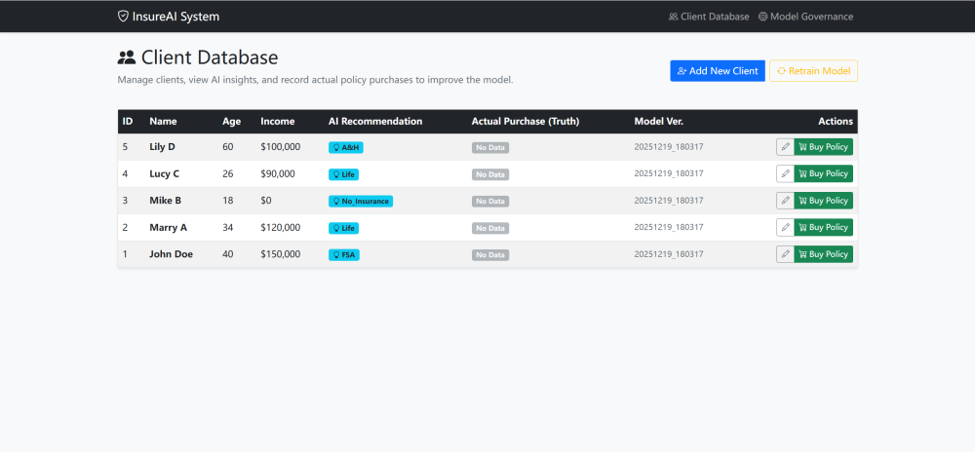

6.2 Real-Time Inference
When adding a new client, the system captures features and triggers the prediction engine in real-time.
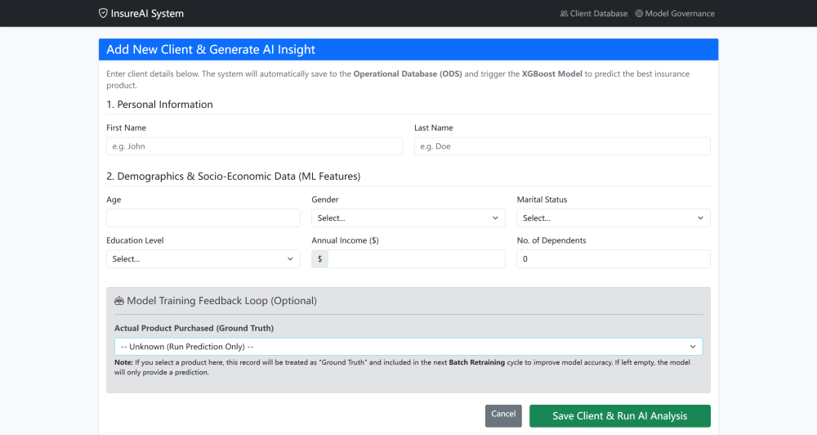
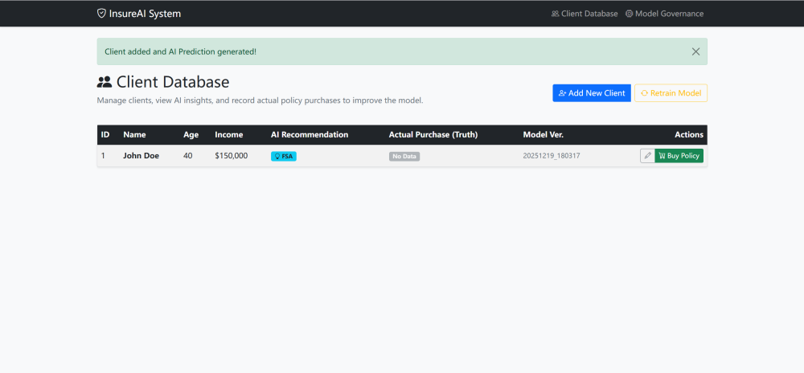

6.3 Closed-Loop: Purchase & Auto-Retraining
Upon confirming a policy purchase, the system detects if the labeled data threshold has been met. If so, it triggers the retraining pipeline.
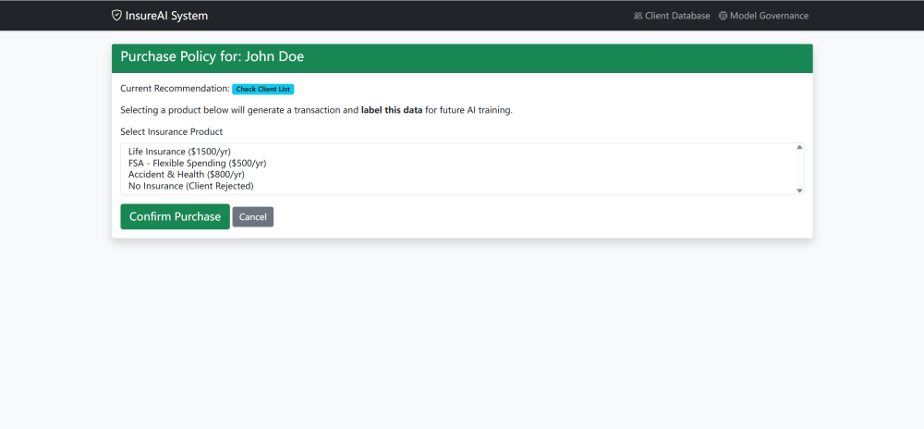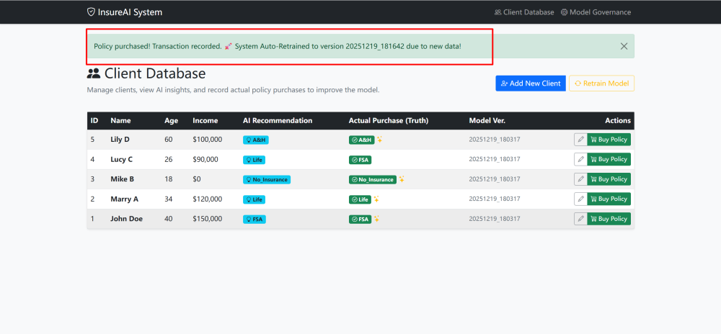
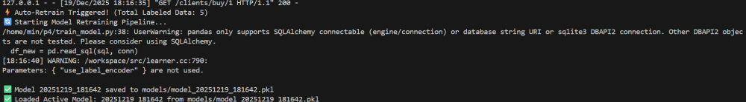

6.4 Model Governance Registry
The administrative view shows the history of model versions, indicating which model is currently "Active" in production.
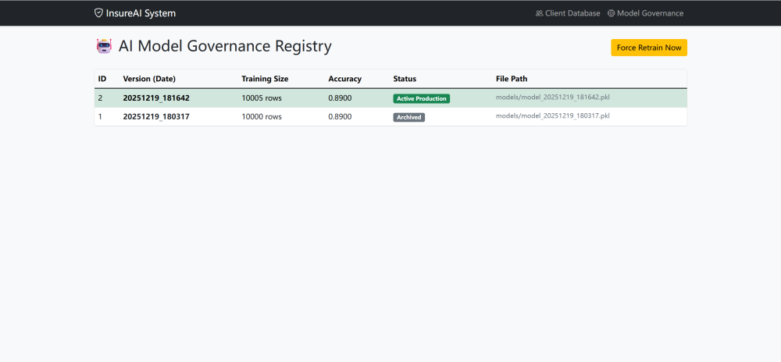

6.5 Manual Retrain Trigger (Optional)
In addition to the automated feedback loop, the system empowers administrators to manually initiate the retraining pipeline. This is particularly useful after bulk data uploads or immediate model updates.
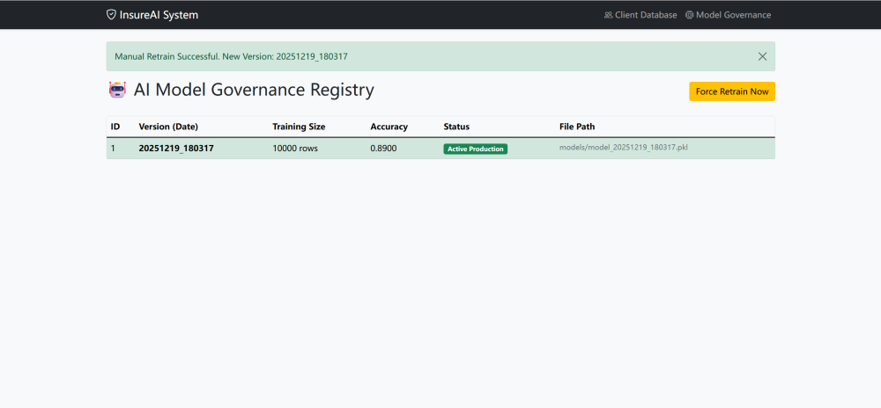

6.6 Data Correction & Updates
Real-world data is dynamic. The system provides a dedicated interface to update client demographics (e.g., significant salary increases or changes in marital status). These updates are immediately reflected in the Operational Data Store (ODS), ensuring that the data quality remains high for future training cycles.
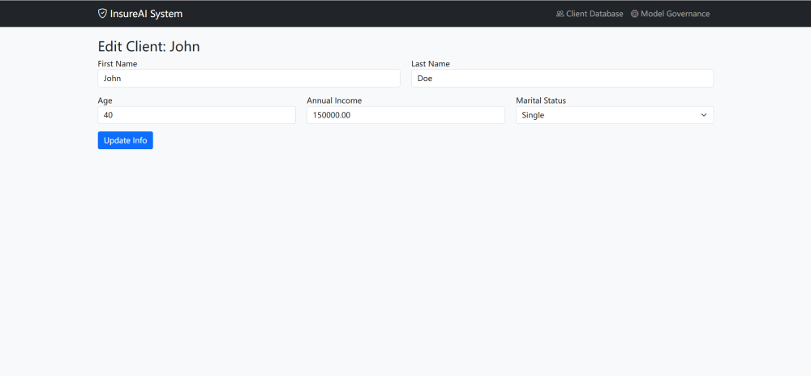

7. Conclusion
This project successfully demonstrates a modern End-to-End Enterprise Architecture. By integrating a transactional relational database (OLTP) with an automated machine learning pipeline, we have created a system that not only manages data but actively learns from it. The use of advanced database techniques like partitioning and indexing, combined with a robust governance framework, ensures the system is performant, scalable, and reliable.

